UNITED STATES

SECURITIES AND EXCHANGE COMMISSION
WASHINGTON, D.C. 20549

SCHEDULE TO

Tender Offer Statement Pursuant to Section 14(d)(1) or 13(e)(1)

of the Securities Exchange Act of 1934

OYSTER POINT PHARMA, INC.

(Name of Subject Company)

IRIS PURCHASER INC.

(Offeror)

A Wholly Owned Subsidiary of

VIATRIS INC.

(Parent of Offeror)

COMMON STOCK, PAR VALUE $0.01 PER SHARE

(Title of Class of Securities)

69242L106

(CUSIP Number of Class of Securities)

Brian Roman

Global General Counsel

Viatris Inc.

1000 Mylan Boulevard

Canonsburg, Pennsylvania 15317

(724) 514-1800
(Name, address and telephone number of person authorized to receive notices and communications on behalf of filing persons)

with copies to:

Mark I. Greene

Andrew M. Wark

Cravath, Swaine & Moore LLP

825 Eighth Avenue

New York, NY 10019

(212) 474-1000

 | CALCULATION OF FILING FEE
Transaction Valuation |  | Amount of Filing Fee
N/A* |  | N/A*
- A filing fee is not required in connection with this filing as it relates solely to preliminary communications made before the commencement of the tender offer.

- Check the box if any part of the fee is offset as provided by Rule 0-11(a)(2) and identify the filing with which the offsetting fee was previously paid. Identify the previous filing by registration statement number, or the Form or Schedule and the date of its filing.

Amount Previously Paid: N/A

Form or Registration No.: N/A

Filing Party: N/A

Date Filed: N/A

- Check the box if the filing relates solely to preliminary communications made before the commencement of a tender offer.

Check the appropriate boxes below to designate any transactions to which the statement relates:

- third-party tender offer subject to Rule 14d-1. ☐ issuer tender offer subject to Rule 13e-4.
☐ going-private transaction subject to Rule 13e-3. ☐ amendment to Schedule 13D under Rule 13d-2.

Check the following box if the filing is a final amendment reporting the results of the tender offer: ☐

If applicable, check the appropriate box(es) below to designate the appropriate rule provision(s) relied upon:

- Rule 13e-4(i) (Cross-Border Issuer Tender Offer)

- Rule 14d-1(d) (Cross-Border Third-Party Tender Offer)

This filing relates solely to pre-commencement communications made before the commencement of a planned tender offer by Iris Purchaser Inc., a Delaware corporation (“Purchaser”), a wholly owned subsidiary of Viatris Inc., a Delaware corporation (“Viatris”), for all of the outstanding shares of common stock, par value $0.01 per share, of Oyster Point Pharma, Inc., a Delaware corporation (“Oyster”), pursuant to the Agreement and Plan of Merger, dated as of November 7, 2022, by and among Viatris, Purchaser and Oyster (the “Merger Agreement”).

Additional Information

The tender offer for the outstanding shares of Oyster common stock referenced in this communication has not yet commenced. This document is for informational purposes only and it is neither an offer to purchase nor a solicitation of an offer to sell shares of Oyster’s common stock, nor is it a substitute for the tender offer materials that Viatris and Oyster will file with the United States Securities and Exchange Commission (the “SEC”) on Schedule TO. At the time any such tender offer is commenced, Viatris will file a Tender Offer Statement, containing an offer to purchase, a form of letter of transmittal and other related tender offer documents with the SEC, and Oyster will file a Solicitation/Recommendation Statement relating to such tender offer with the SEC. Oyster’s stockholders are strongly advised to read these tender offer materials carefully and in their entirety when they become available, as they may be amended from time to time, because they will contain important information about such tender offer that Oyster’s stockholders should consider prior to making any decisions with respect to such tender offer. Once filed, stockholders of Oyster will be able to obtain a free copy of these documents at the website maintained by the SEC at www.sec.gov.

Cautionary Statement Regarding Forward-Looking Statements

This communication contains “forward-looking statements”. These statements are made pursuant to the safe harbor provisions of the Private Securities Litigation Reform Act of 1995. Such forward-looking statements may include, without limitation, statements about the proposed transaction (in which, among other things, Viatris, through its indirect wholly-owned subsidiary, will commence a cash tender offer to acquire all of the outstanding shares of common stock, $0.001 par value per share, of Oyster and, following the consummation of such tender offer, for such wholly-owned subsidiary of Viatris to be merged with and into Oyster), the expected timetable for completing the proposed transaction, the benefits and synergies of the proposed transaction, the ability to complete the transaction or to satisfy the various closing conditions, future opportunities for Viatris or Oyster and either of their products and any other statements regarding Viatris’ or Oyster’s future operations, strategic initiatives, financial or operating results, capital allocation, dividend policy and payments, debt ratio and covenants, anticipated business levels, future earnings, planned activities, anticipated growth, market opportunities, strategies, competitions, commitments, confidence in future results, efforts to create, enhance or otherwise unlock the value of Viatris’ unique global platform, and other expectations and targets for future periods. Forward-looking statements may often be identified by the use of words such as “will”, “may”, “could”, “should”, “would”, “project”, “believe”, “anticipate”, “expect”, “plan”, “estimate”, “forecast”, “potential”, “pipeline”, “intend”, “continue”, “target”, “seek” and variations of these words or comparable words. Because forward-looking statements inherently involve risks and uncertainties, actual future results may differ materially from those expressed or implied by such forward-looking statements. Factors that could cause or contribute to such differences include, but are not limited to:

- the ability of Viatris and Oyster to meet expectations regarding the timing, completion and accounting and tax treatments of the proposed transaction;

- the ability of Viatris and Oyster to consummate the proposed transaction;

- the conditions to the completion of the proposed transaction (including, but not limited to, that the stockholders of Oyster tender and do not withdraw, in the aggregate, at least 50% plus one of the outstanding shares of Oyster common stock) not being satisfied or waived on the anticipated timeframe or at all;

- the regulatory approvals required for the proposed transaction not being obtained on the terms expected or on the anticipated schedule or at all;

- the possibility that competing offers may be made;

- the possibility that Viatris may be unable to achieve expected benefits, synergies and operating efficiencies in connection with the proposed transaction within the expected timeframe or at all or to successfully integrate Viatris and Oyster;

- the potential impact of public health outbreaks, epidemics and pandemics, including the ongoing challenges and uncertainties posed by the COVID-19 pandemic;

- Viatris’ or Oyster’s failure to achieve expected or targeted future financial and operating performance and results;

- the proposed transaction’s contingent value right payment, including Oyster’s ability to achieve the milestone(s) that trigger the contingent value right payment;

- actions and decisions of healthcare and pharmaceutical regulators;

- changes in relevant laws and regulations, including but not limited to changes in tax, healthcare and pharmaceutical laws and regulations globally (including the impact of potential tax reform in the U.S.);

- the ability to attract and retain key personnel;

- Viatris’ or Oyster’s liquidity, capital resources and ability to obtain financing;

- any regulatory, legal or other impediments to Viatris’ or Oyster’s ability to bring new products to market, including but not limited to “at-risk launches”;

- success of clinical trials and Viatris’ or Oyster’s (or, with respect to each, its partners’) ability to execute on new product opportunities and develop, manufacture and commercialize products;

- any changes in or difficulties with Viatris’ or Oyster’s manufacturing facilities, including with respect to inspections, remediation and restructuring activities, supply chain or inventory or the ability to meet anticipated demand;

- the scope, timing and outcome of any ongoing legal proceedings, including government inquiries or investigations;

- any significant breach of data security or data privacy or disruptions to Viatris’ or Oyster’s information technology systems;

- risks associated with having significant operations globally;

- the ability to protect Viatris’ or Oyster’s intellectual property and preserve their respective intellectual property rights, including, but not limited to, the risk that Oyster’s European patent related to OC-01 (sold in the Unites States as TYRVAYA® (varenicline solution) Nasal Spray) will be invalidated, or will have its claims amended, through opposition proceedings that are currently pending, which could have a material impact on Oyster’s ability to commercialize OC-01 in Europe and could permit the sale of competing products by third parties in Europe;

- changes in third-party relationships;

- the effect of any changes in Viatris’ or Oyster’s (or, with respect to each, its partners’) customer and supplier relationships and customer purchasing patterns, including customer loss and business disruption being greater than expected following the proposed transaction;

- the impacts of competition, including decreases in sales or revenues as a result of the loss of market exclusivity for certain products;

- changes in the economic and financial conditions of Viatris or Oyster (or, with respect to each, its partners);

- uncertainties regarding future demand, pricing and reimbursement for Viatris’ or Oyster’s products;

- uncertainties and matters beyond the control of management, including but not limited to general political and economic conditions, inflation rates and global exchange rates; and

- inherent uncertainties involved in the estimates and judgments used in the preparation of financial statements, and the providing of estimates of financial measures, in accordance with U.S. GAAP and related standards or on an adjusted basis.

For more detailed information on the risks and uncertainties associated with Viatris, see the risks described in Part I, Item 1A in Viatris’ 2021 Form 10-K, Quarterly Reports on Form 10-Q and Viatris’ other filings with the SEC. You can access Viatris’ filings with the SEC through the SEC website at www.sec.gov or through our website, and Viatris strongly encourages you to do so. Viatris routinely posts information that may be important to investors on our website at investor.viatris.com, and we use this website address as a means of disclosing material information to the public in a broad, non-exclusionary manner for purposes of the SEC’s Regulation Fair Disclosure (Reg FD). The contents of our website are not incorporated by reference in this communication and shall not be deemed “filed” under the Securities Exchange Act of 1934, as amended. Viatris undertakes no obligation to update any statements herein for revisions or changes after the filing date of this communication other than as required by law.

 |  |  | EXHIBIT INDEX
Exhibit No. |  | Description
99.1 |  | Portions of Viatris Investor Presentation, dated November 7, 2022.
99.2 |  | Viatris press release announcing two acquisitions and its plan to provide a strategic updated on its February 2022 investor event,
 |  | dated November 7, 2022.
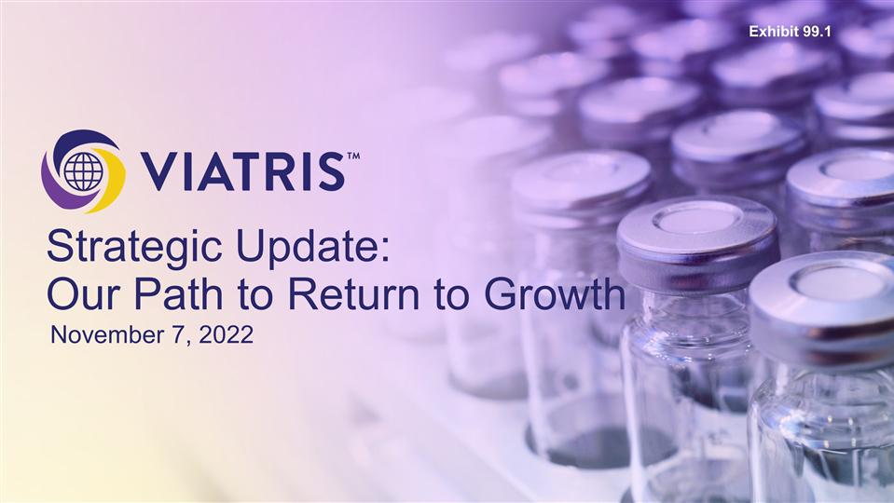

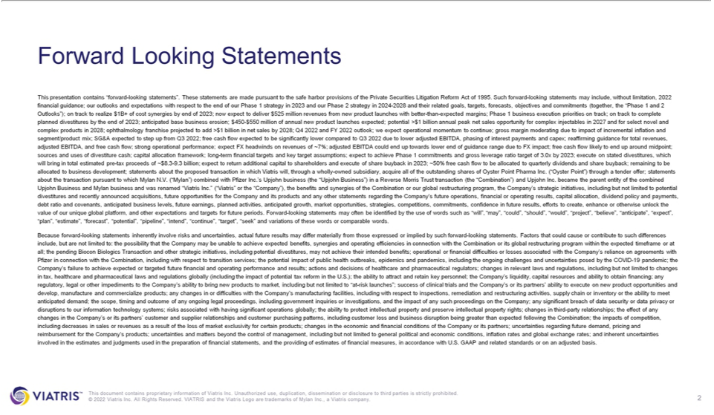

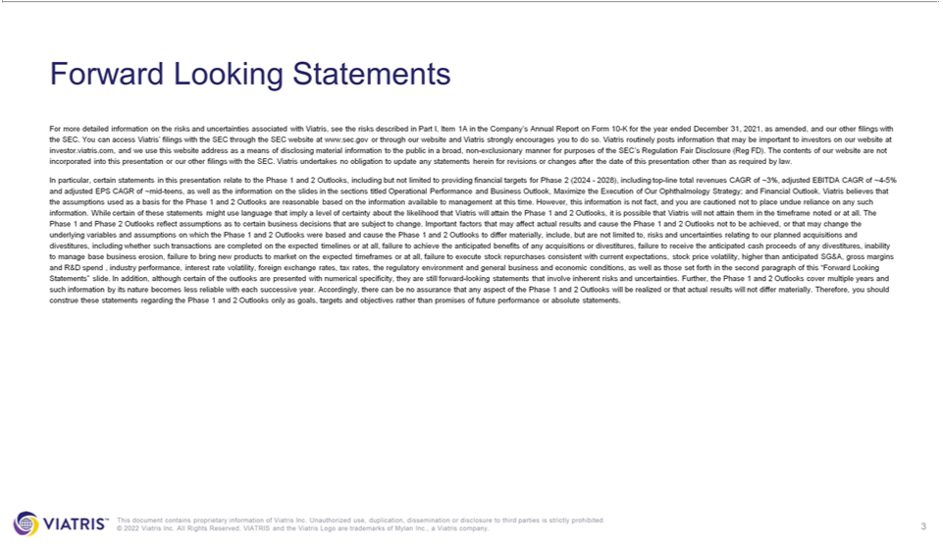

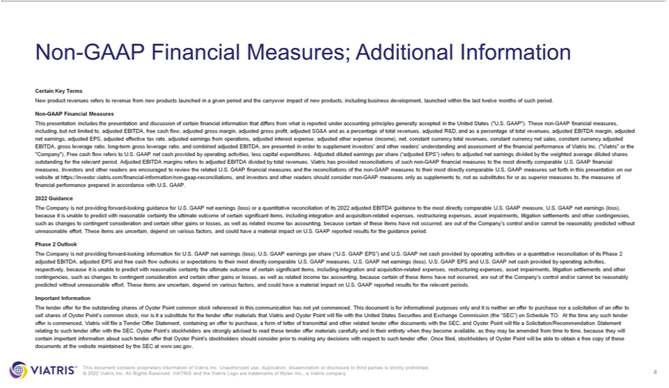

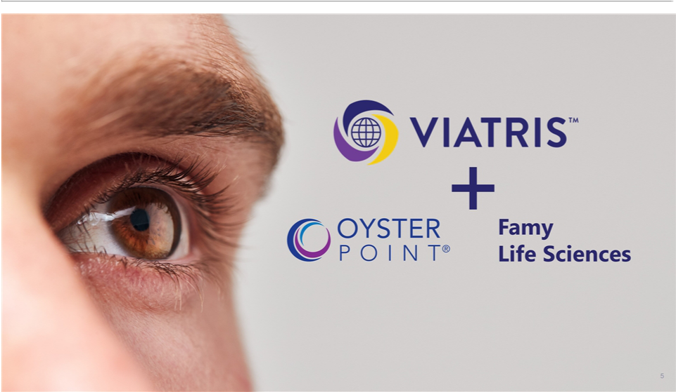

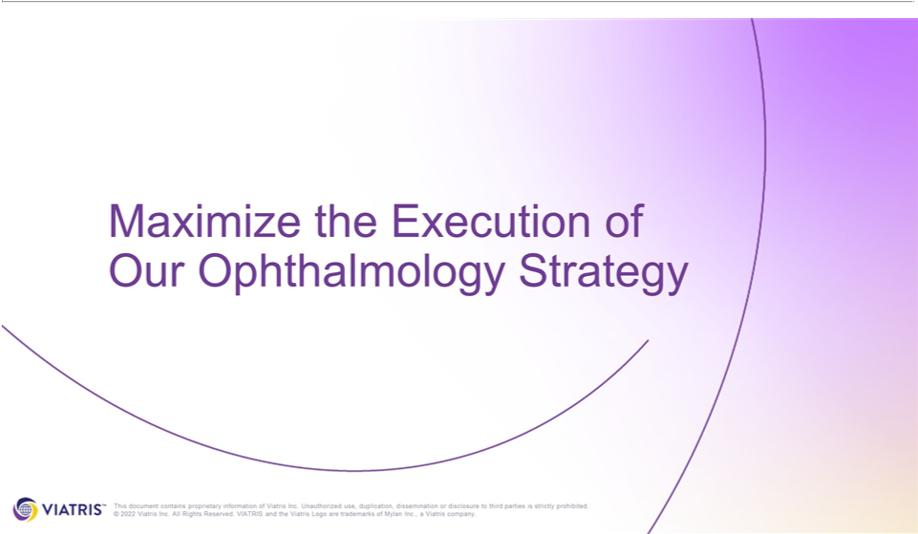

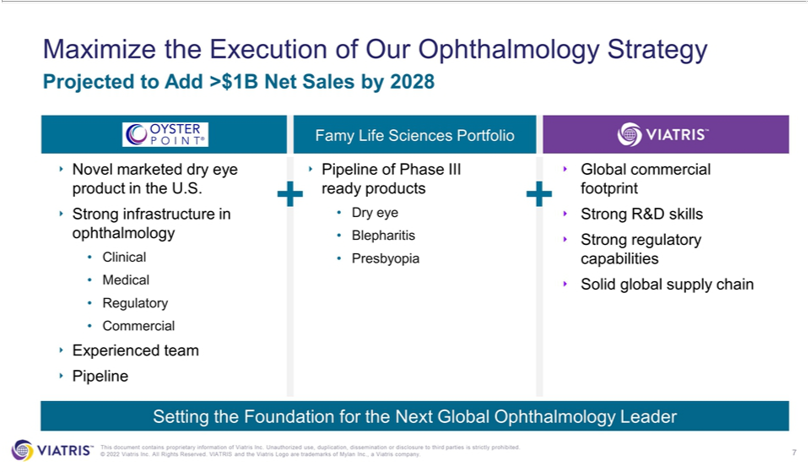

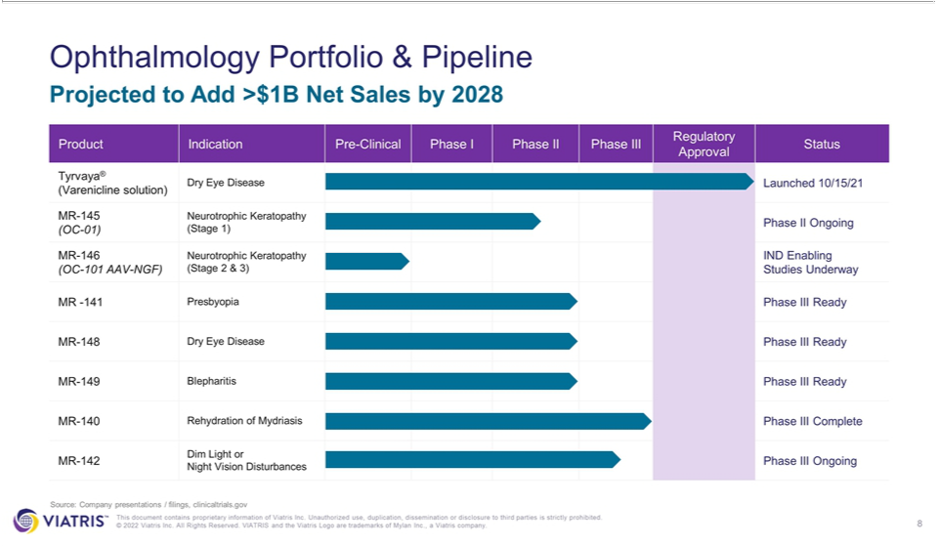

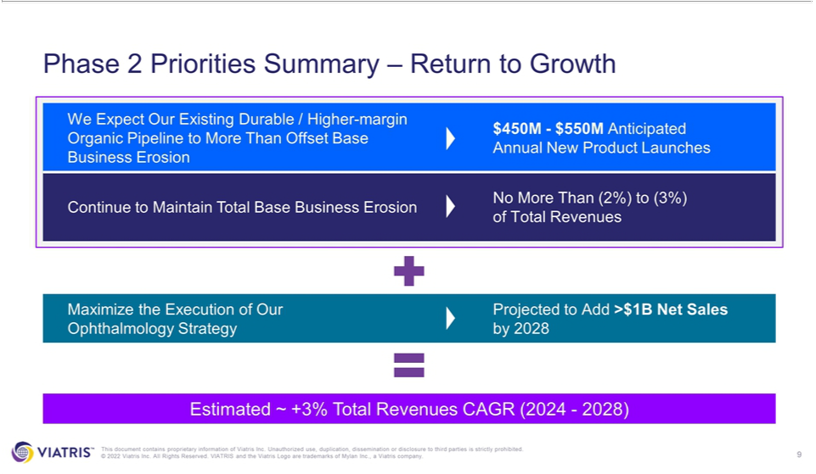

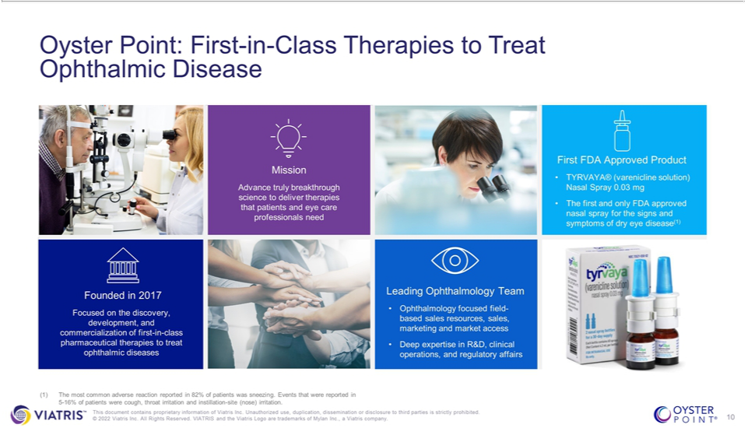

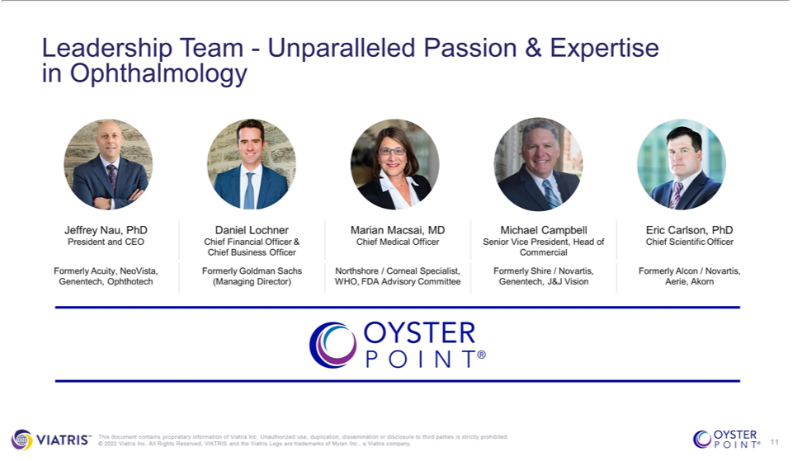

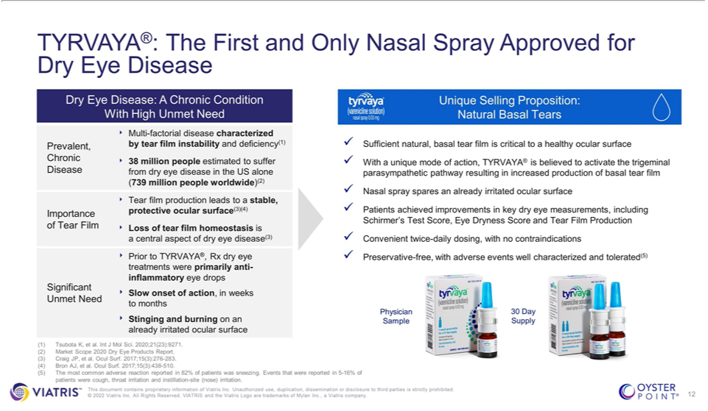

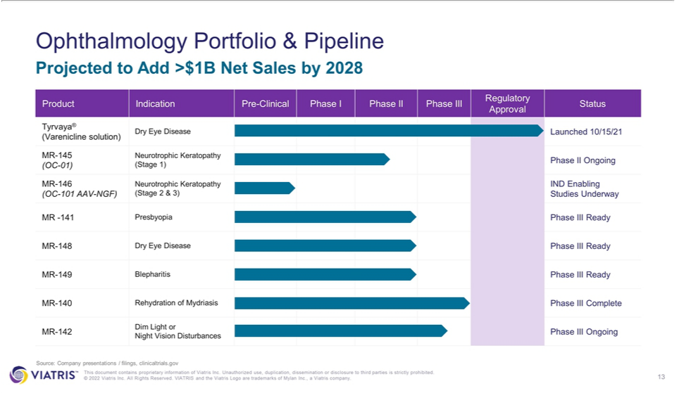

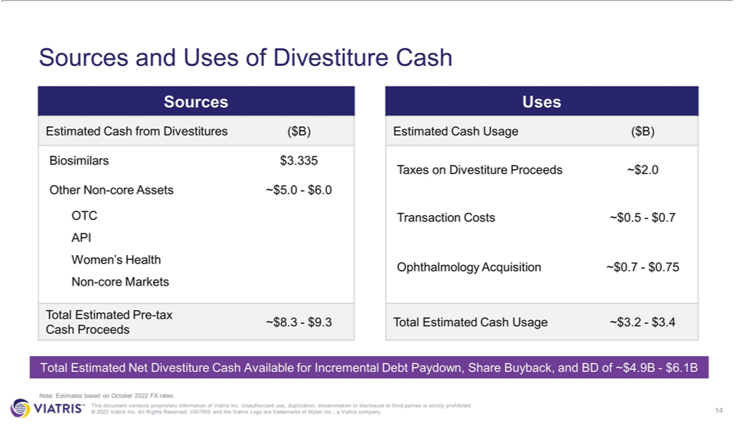

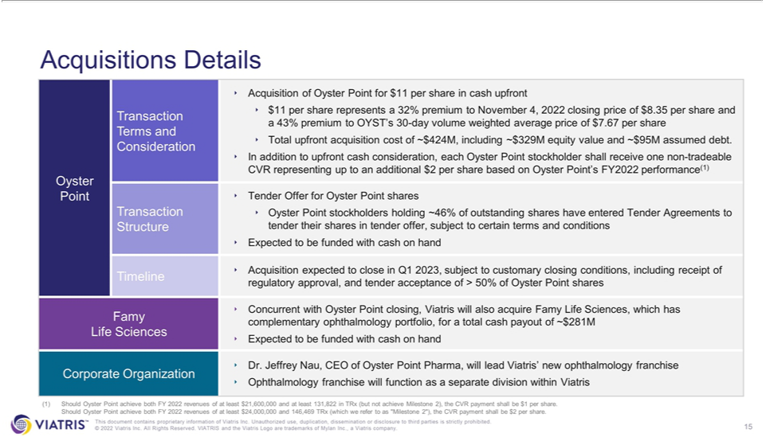

Exhibit 99.2
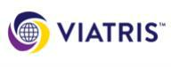

Viatris Announces Two Acquisitions to Create What it Expects to be a Leading Ophthalmology Franchise; Plans to Provide Strategic Update on its February 2022 Investor Event

- Expects Biocon Biologics Transaction to Close Shortly

- Intends to Begin Executing on Stock Repurchase Program

- Enters Agreements to Acquire Oyster Point Pharma and Famy Life Sciences for Aggregate of $700-$750 Million in Cash; Expects to Close in Q1 2023

- Expects Combination of Acquisitions and Share Repurchases to be Accretive to Adjusted EPS in 2023 on a Standalone Basis

- Anticipates Acquisitions Will Have the Potential to Add at Least $1 Billion in Net Sales and at Least $500 Million in Adjusted EBITDA by 2028

- Reaffirms Total Pre-Tax Proceeds Expected from Biocon Transaction and Certain Non-Core Asset Divestitures to be up to Approximately $9 Billion

- Provides Financial Targets for 2024 to 2028, Including Top-Line Total Revenues CAGR of ~3%, Adjusted EBITDA CAGR of ~4-5%, and Adjusted EPS CAGR of ~Mid-Teens

- Reiterates Commitment to Maintaining its Investment Grade Rating; Continues to Expect to Fully Meet Phase 1 Financial Commitments by End of 2023, Including Reducing its Gross Leverage Ratio to Approximately 3x

PITTSBURGH – November 7, 2022 – Viatris Inc. (NASDAQ: VTRS), a global healthcare company, today announced that it intends to create an ophthalmology franchise by acquiring Oyster Point Pharma and Famy Life Sciences and that it will provide a strategic update on its February 2022 Investor Event in a conference call and live webcast today at 8:30 a.m. ET.

Under the terms of a definitive agreement, Viatris has agreed to acquire Oyster Point for $11 per share in cash upfront through a tender offer. In addition, each Oyster Point stockholder will receive one non-tradeable contingent value right, representing up to an additional $2 per share contingent upon Oyster Point’s achieving certain metrics based on full year 2022 performance.

Viatris is targeting to close the acquisition of Oyster Point in Q1 2023, subject to customary closing conditions, including receipt of regulatory approval, and tender acceptance of more than 50% of Oyster Point shares.

Concurrently, the Company also expects to acquire Famy Life Sciences, which has a complementary ophthalmology portfolio.

The Company anticipates these acquisitions have the potential to add at least $1 billion in sales by 2028. As a result of the expected strong top-line growth, the Company anticipates it will also add at least $500 million in adjusted EBITDA by 2028.

Together, the two acquisitions have an aggregate purchase price of approximately $700-$750 million which Viatris expects to fund with cash on hand.

Ophthalmology is one of the key therapeutic areas of focus that the Company identified in February. With the combination of Viatris’ global commercial footprint, R&D and regulatory capabilities and supply chain, along with Oyster Point’s deep knowledge of the ophthalmology space from a clinical, medical, regulatory and commercial perspective—including a commercial asset, Tyrvaya®, for the treatment of dry eye disease— and Famy Life Science’s Phase III-ready pipeline, the Company believes it has the foundation to create a leading global ophthalmology franchise, accelerating efforts to address the unmet needs of patients with ophthalmic disease and the eye care professionals who treat them. The ophthalmology franchise will function as a separate division within the company and will be led by current Oyster Point CEO, Jeff Nau Ph.D. upon the closing of the transaction.

Executive Comments

Viatris Executive Chairman Robert J. Coury said: “Two years into our journey as Viatris, I am extremely pleased with the strength and execution of our business. After seven straight quarters of delivering strong results, we are well on our way to completing all Phase 1 commitments and can now turn our focus to setting up for Phase 2 — 2024 and beyond. We are pleased to announce this morning our agreements to acquire two high quality businesses to form a new ophthalmology franchise within Viatris. Oyster Point, under the leadership of Dr. Jeff Nau, has a well-respected reputation within the ophthalmology space, and we look forward to having Jeff join the Viatris management team as leader of our ophthalmology franchise following the closing of the transactions. In addition to discussing these acquisitions, I look forward to sharing more updates to our February 2022 Investor Event during our conference call at 8:30 a.m.”

Viatris CEO Michael Goettler said: “We’ve been talking about the potential power of our Global Healthcare Gateway since we launched Viatris, that is why I am especially excited that the two ophthalmology acquisitions we announced today came about directly as the result of the Global Healthcare Gateway. These acquisitions bring us an innovative growth asset, Tyrvaya®, and five additional Phase III or Phase III-ready programs that give us a significant head-start in creating a leading ophthalmology franchise.”

Oyster Point CEO Jeff Nau, Ph.D. said: “When we started Oyster Point Pharma in 2017, we embarked on a journey to build a leading company within the eye care space. Building on our success in the U.S. market, we are excited to join Viatris to now bring the strengths of Oyster Point to help build a leading global ophthalmology business. We believe that together we will meaningfully shape the future of eye care to address the unmet needs of patients with ophthalmic disease and the eye care professionals who take care of them.”

Conference Call and Webcast

Viatris will host a conference call and live webcast today at 8:30 a.m. ET with Executive Chairman Robert J. Coury, Chief Executive Officer Michael Goettler, President Rajiv Malik, Chief Financial Officer Sanjeev Narula and Oyster Point CEO Jeffrey Nau, Ph.D.

Investors and the general public can listen to the live webcast at investor.viatris.com or by calling 800.225.9448 or 203.518.9708 for international callers (Conference ID: VTRSQ322). The “Viatris Q3 Earnings Presentation”, which will be referenced during the call, can also be found at investor.viatris.com. An archived replay of the webcast will be available following the live event and can be accessed at the same location for a limited time.

Advisors

Citigroup Global Markets Inc. is providing strategic advice and acting as financial advisor to the Company in relation to the planned acquisition of Oyster Point Pharma, Inc. Outside legal counsel is being provided by Cravath, Swaine & Moore LLP.

About Viatris

Viatris Inc. (NASDAQ: VTRS) is a global healthcare company empowering people worldwide to live healthier at every stage of life. We provide access to medicines, advance sustainable operations, develop innovative solutions and leverage our collective expertise to connect more people to more products and services through our one-of-a-kind Global Healthcare Gateway®. Formed in November 2020, Viatris brings together scientific, manufacturing and distribution expertise with proven regulatory, medical, and commercial capabilities to deliver high-quality medicines to patients in more than 165 countries and territories. Viatris’ portfolio comprises more than 1,400 approved molecules across a wide range of therapeutic areas, spanning both non-communicable and infectious diseases, including globally recognized brands, complex generic and branded medicines, a portfolio of biosimilars and a variety of over-the-counter consumer products. With approximately 37,000 colleagues globally, Viatris is headquartered in the U.S., with global centers in Pittsburgh, Shanghai and Hyderabad, India. Learn more at viatris.com and investor.viatris.com, and connect with us on Twitter at @ViatrisInc, LinkedIn and YouTube.

Forward Looking Statements

This press release contains “forward-looking statements”. These statements are made pursuant to the safe harbor provisions of the Private Securities Litigation Reform Act of 1995. Such forward-looking statements may include, without limitation, 2022 financial guidance; our outlooks and expectations with respect to the end of our Phase I strategy in 2023 and our Phase II strategy in 2024-2028 and their related goals, targets, forecasts, objectives and commitments (together, the “Phase I and II Outlooks”); expects Biocon Biologics transaction to close shortly; intends to begin executing on stock repurchase program; enters agreements to acquire Oyster Point Pharma and Famy Life Sciences for aggregate of $700-$750 million in cash; expects to close in Q1 2023; expects combination of acquisitions and share repurchases to be accretive to adjusted EPS in 2023 on a standalone basis; anticipates acquisitions will have the potential to add at least $1 billion in net sales and at least $500 million in adjusted EBITDA by 2028; reaffirms total pre-tax proceeds expected from Biocon Transaction and certain non-core asset divestitures to be up to approximately $9 billion; provides financial targets for 2024 to 2028, including top-line total revenues CAGR of ~3%, adjusted EBITDA CAGR of ~4-5%, and adjusted EPS CAGR of ~mid-teens; reiterates commitment to maintaining its investment grade rating; continues to expect to fully meet Phase 1 financial commitments by end of 2023, including reducing its gross leverage ratio to approximately 3x; it intends to create an ophthalmology franchise by acquiring Oyster Point Pharma and Famy Life Sciences; Viatris is targeting to close the acquisition of Oyster Point in Q1 2023, subject to customary closing conditions, including receipt of regulatory approval, and tender acceptance of more than 50% of Oyster Point shares; the Company also expects to acquire Famy Life Sciences, which has a complementary ophthalmology portfolio; after seven straight quarters of delivering strong results, we are well on our way to completing all Phase 1 commitments and can now turn our focus to setting up for Phase 2—2024 and beyond; these acquisitions bring us an innovative growth asset, Tyrvaya®, and five additional Phase III or Phase III-ready programs that give us a significant head-start in creating a leading ophthalmology franchise; statements about the

proposed transaction in which Viatris will, through a wholly-owned subsidiary, acquire all of the outstanding shares of Oyster Point Pharma Inc. (“Oyster Point”) through a tender offer; statements about the transaction pursuant to which Mylan N.V. (“Mylan”) combined with Pfizer Inc.’s Upjohn business (the “Upjohn Business”) in a Reverse Morris Trust transaction (the “Combination”) and Upjohn Inc. became the parent entity of the combined Upjohn Business and Mylan business and was renamed “Viatris Inc.” (“Viatris” or the “Company”), the benefits and synergies of the Combination or our global restructuring program, the Company’s strategic initiatives, including but not limited to potential divestitures and recently announced acquisitions, future opportunities for the Company and its products and any other statements regarding the Company’s future operations, financial or operating results, capital allocation, dividend policy and payments, debt ratio and covenants, anticipated business levels, future earnings, planned activities, anticipated growth, market opportunities, strategies, competitions, commitments, confidence in future results, efforts to create, enhance or otherwise unlock the value of our unique global platform, and other expectations and targets for future periods. Forward-looking statements may often be identified by the use of words such as “will”, “may”, “could”, “should”, “would”, “project”, “believe”, “anticipate”, “expect”, “plan”, “estimate”, “forecast”, “potential”, “pipeline”, “intend”, “continue”, “target”, “seek” and variations of these words or comparable words.

Because forward-looking statements inherently involve risks and uncertainties, actual future results may differ materially from those expressed or implied by such forward-looking statements. Factors that could cause or contribute to such differences include, but are not limited to: the possibility that the Company may be unable to achieve expected benefits, synergies and operating efficiencies in connection with the Combination or its global restructuring program within the expected timeframe or at all; the pending Biocon Biologics Transaction and other strategic initiatives, including potential divestitures, may not achieve their intended benefits; operational or financial difficulties or losses associated with the Company’s reliance on agreements with Pfizer in connection with the Combination, including with respect to transition services; the potential impact of public health outbreaks, epidemics and pandemics, including the ongoing challenges and uncertainties posed by the COVID-19 pandemic; the Company’s failure to achieve expected or targeted future financial and operating performance and results; actions and decisions of healthcare and pharmaceutical regulators; changes in relevant laws and regulations, including but not limited to changes in tax, healthcare and pharmaceutical laws and regulations globally (including the impact of potential tax reform in the U.S.); the ability to attract and retain key personnel; the Company’s liquidity, capital resources and ability to obtain financing; any regulatory, legal or other impediments to the Company’s ability to bring new products to market, including but not limited to “at-risk launches”; success of clinical trials and the Company’s or its partners’ ability to execute on new product opportunities and develop, manufacture and commercialize products; any changes in or difficulties with the Company’s manufacturing facilities, including with respect to inspections, remediation and restructuring activities, supply chain or inventory or the ability to meet anticipated demand; the scope, timing and outcome of any ongoing legal proceedings, including government inquiries or investigations, and the impact of any such proceedings on the Company; any significant breach of data security or data privacy or disruptions to our information technology systems; risks associated with having significant operations globally; the ability to protect intellectual property and preserve intellectual property rights; changes in third-party relationships; the effect of any changes in the Company’s or its partners’ customer and supplier relationships and customer purchasing patterns, including customer loss and business disruption being greater than expected following the Combination; the impacts of competition, including decreases in sales or revenues as a result of the loss of market exclusivity for certain products; changes in the economic and financial conditions of the Company or its partners; uncertainties regarding future demand, pricing and reimbursement for the Company’s products; uncertainties and matters

beyond the control of management, including but not limited to general political and economic conditions, inflation rates and global exchange rates; and inherent uncertainties involved in the estimates and judgments used in the preparation of financial statements, and the providing of estimates of financial measures, in accordance with U.S. GAAP and related standards or on an adjusted basis.

For more detailed information on the risks and uncertainties associated with Viatris, see the risks described in Part I, Item 1A in the Company’s Annual Report on Form 10-K for the year ended December 31, 2021, as amended, and our other filings with the SEC. You can access Viatris’ filings with the SEC through the SEC website at www.sec.gov or through our website and Viatris strongly encourages you to do so. Viatris routinely posts information that may be important to investors on our website at investor.viatris.com, and we use this website address as a means of disclosing material information to the public in a broad, non-exclusionary manner for purposes of the SEC’s Regulation Fair Disclosure (Reg FD). The contents of our website are not incorporated into this release or our other filings with the SEC. Viatris undertakes no obligation to update any statements herein for revisions or changes after the date of this release other than as required by law.

In particular, certain statements in this release relate to the Phase I and II Outlooks, including but not limited to providing financial targets for Phase 2 (2024 to 2028), including top-line total revenues CAGR of ~3%, adjusted EBITDA CAGR of ~4-5% and adjusted EPS CAGR of ~mid-teens, expecting total pre-tax proceeds expected from the Biocon Biologics Transaction and certain non-core asset divestitures to be up to approximately $9 billion, anticipating combined assets from the two transactions announced today to have the potential to add at least $1 billion in net sales and at least

$500 million in adjusted EBITDA by 2028, and our gross leverage ratio target. Viatris believes that the assumptions used as a basis for the Phase I and II Outlooks are reasonable based on the information available to management at this time. However, this information is not fact, and you are cautioned not to place undue reliance on any such information. While certain of these statements might use language that imply a level of certainty about the likelihood that Viatris will attain the Phase I and II Outlooks, it is possible that Viatris will not attain them in the timeframe noted or at all. The Phase I and Phase II Outlooks reflect assumptions as to certain business decisions that are subject to change. Important factors that may affect actual results and cause the Phase I and II Outlooks not to be achieved, or that may change the underlying variables and assumptions on which the Phase I and II Outlooks were based and cause the Phase I and II Outlooks to differ materially, include, but are not limited to, risks and uncertainties relating to our planned acquisitions and divestitures, including whether such transactions are completed on the expected timelines or at all, failure to achieve the anticipated benefits of any acquisitions or divestitures, failure to receive the anticipated cash proceeds of any divestitures, inability to manage base business erosion, failure to bring new products to market on the expected timeframes or at all, failure to execute stock repurchases consistent with current expectations, stock price volatility, higher than anticipated SG&A, gross margins and R&D spend, industry performance, interest rate volatility, foreign exchange rates, tax rates, the regulatory environment and general business and economic conditions, as well as those set forth in the second paragraph of this “Forward Looking Statements” slide. In addition, although certain of the outlooks are presented with numerical specificity, they are still forward-looking statements that involve inherent risks and uncertainties. Further, the Phase I and II Outlooks cover multiple years and such information by its nature becomes less reliable with each successive year. Accordingly, there can be no assurance that any aspect of the Phase I and II Outlooks will be realized or that actual results will not differ materially. Therefore, you should construe these statements regarding the Phase I and II Outlooks only as goals, targets and objectives rather than promises of future performance or absolute statements.

Non-GAAP Financial Measures

This press release includes the presentation and discussion of certain financial information that differs from what is reported under accounting principles generally accepted in the United States (“U.S. GAAP”). These non-GAAP financial measures, including, but not limited to, adjusted EBITDA, free cash flow, adjusted EPS and gross leverage ratio target are presented in order to supplement investors’ and other readers’ understanding and assessment of the financial performance of Viatris. Free cash flow refers to U.S. GAAP net cash provided by operating activities, less capital expenditures. Adjusted diluted earnings per share (“adjusted EPS”) refers to adjusted net earnings divided by the weighted average diluted shares outstanding for the relevant period. For the third quarter of 2022, Viatris calculated adjusted net earnings as U.S. GAAP net earnings (loss) adjusted for purchase accounting related amortization, litigation settlements and other contingencies, net, interest expense, acquisition related cost, restructuring related costs, share-based compensation expense, other special items included in cost of sales, SG&A expense and other (income) expense, net, and the tax effect of the above items and other income tax related items. For the third quarter of 2022, Viatris calculated adjusted EBITDA as U.S. GAAP net earnings (loss) adjusted for income tax provision (benefit), interest expense and depreciation and amortization (to get to EBITDA) and further adjusted for share-based compensation expense, litigation settlements and other contingencies, net and restructuring, acquisition related and other special items. Viatris has provided reconciliations of such non-GAAP financial measures to the most directly comparable U.S. GAAP financial measures. Investors and other readers are encouraged to review the related U.S. GAAP financial measures and the reconciliations of the non-GAAP measures to their most directly comparable U.S. GAAP measures set forth in this release on our website at https://investor.viatris.com/financial-information/non-gaap-reconciliations, and investors and other readers should consider non-GAAP measures only as supplements to, not as substitutes for or as superior measures to, the measures of financial performance prepared in accordance with U.S. GAAP.

Phase II Outlook

The Company is not providing forward-looking information for U.S. GAAP net earnings (loss), U.S. GAAP earnings per share (“U.S. GAAP EPS”) and U.S. GAAP net cash provided by operating activities or a quantitative reconciliation of its Phase II adjusted EBITDA, adjusted EPS and free cash flow outlooks or expectations to their most directly comparable U.S. GAAP measures, U.S. GAAP net earnings (loss), U.S. GAAP EPS and U.S. GAAP net cash provided by operating activities, respectively, because it is unable to predict with reasonable certainty the ultimate outcome of certain significant items, including integration and acquisition-related expenses, restructuring expenses, asset impairments, litigation settlements and other contingencies, such as changes to contingent consideration and certain other gains or losses, as well as related income tax accounting, because certain of these items have not occurred, are out of the Company’s control and/or cannot be reasonably predicted without unreasonable effort. These items are uncertain, depend on various factors, and could have a material impact on U.S. GAAP reported results for the relevant periods.

Gross Leverage Target

The stated forward-looking non-GAAP financial measure of long-term gross leverage target of 3.0x, with a range of 2.8x – 3.2x, is based on the ratio of

- targeted notional gross debt and (ii) targeted Adjusted EBITDA. However, the Company has not quantified future amounts to develop this target but has stated its goal to manage notional gross debt and adjusted earnings and adjusted EBITDA over time in order to generally maintain or reach the target. This target does not reflect Company guidance.

IMPORTANT INFORMATION

The tender offer for the outstanding shares of Oyster Point common stock referenced in this communication has not yet commenced. This document is for informational purposes only and it is neither an offer to purchase nor a solicitation of an offer to sell shares of Oyster Point’s common stock, nor is it a substitute for the tender offer materials that Viatris and Oyster Point will file with the United States Securities and Exchange Commission (the “SEC”) on Schedule TO. At the time any such tender offer is commenced, Viatris will file a Tender Offer Statement, containing an offer to purchase, a form of letter of transmittal and other related tender offer documents with the SEC, and Oyster Point will file a Solicitation/Recommendation Statement relating to such tender offer with the SEC. Oyster Point’s stockholders are strongly advised to read these tender offer materials carefully and in their entirety when they become available, as they may be amended from time to time, because they will contain important information about such tender offer that Oyster Point’s stockholders should consider prior to making any decisions with respect to such tender offer. Once filed, stockholders of Oyster Point will be able to obtain a free copy of these documents at the website maintained by the SEC at www.sec.gov.

Contacts:
MEDIA |  |  |  |  | INVESTORS
+1.724.514.1968 |  |  |  |  | Bill Szablewski
Communications@viatris.com |  |  |  | +1.412.707.2866
 |  |  |  |  | InvestorRelations@viatris.com
Jennifer Mauer |  |  |  |  | William.Szablewski@viatris.com
Jennifer.Mauer@viatris.com
Matt Klein
Matthew.Klein@viatris.com
 |  |  |  | # # #

