UNITED STATES

SECURITIES AND EXCHANGE COMMISSION
WASHINGTON, D.C. 20549

FORM 8-K

CURRENT REPORT

Pursuant to Section 13 or 15(d)
of the Securities Exchange Act of 1934

Date of Report (Date of earliest event reported): February 22, 2021

VIATRIS INC.

(Exact name of registrant as specified in its charter)

Delaware

001-39695

83-4364296

(State or Other Jurisdiction
of Incorporation)

(Commission
File Number)

(I.R.S. Employer
Identification No.)

1000 Mylan Boulevard, Canonsburg, Pennsylvania , 15317

(Address of Principal Executive Offices)

Registrant’s telephone number, including area code: (724) 514-1800

Check the appropriate box below if the Form 8-K filing is intended to simultaneously satisfy the filing obligation of the registrant under any of the following provisions:

- Written communications pursuant to Rule 425 under the Securities Act (17 CFR 230.425)

- Soliciting material pursuant to Rule 14a-12 under the Exchange Act (17 CFR 240.14a-12)

- Pre-commencement communications pursuant to Rule 14d-2(b) under the Exchange Act (17 CFR 240.14d-2 (b))

- Pre-commencement communications pursuant to Rule 13e-4(c) under the Exchange Act (17 CFR 240.13e-4 (c))

Securities registered pursuant to Section 12(b) of the Act:

Title of each class |  | Trading |  | Name of each exchange
 |  | Symbol(s) |  | on which registered
Common Stock, par value $0.01 per share |  | VTRS |  | The NASDAQ Stock Market

Indicate by check mark whether the registrant is an emerging growth company as defined in Rule 405 of the Securities Act of 1933 (§230.405 of this chapter) or Rule 12b-2 of the Securities Exchange Act of 1934 (§240.12b-2 of this chapter).

Emerging growth company ☐

If an emerging growth company, indicate by check mark if the registrant has elected not to use the extended transition period for complying with any new or revised financial accounting standards provided pursuant to Section 13(a) of the Exchange Act. ☐

Item 2.02 Results of Operations and Financial Condition.

As previously disclosed, Viatris Inc. (“Viatris”) will host a conference call and live webcast today, February 22, 2021, at 8 a.m. ET to discuss 2021 financial guidance. A copy of the presentation to be made during the call/webcast, which includes preliminary estimated 2020 measures, is attached hereto as Exhibit 99.1 and is incorporated herein by reference.

Item 7.01 Regulation FD Disclosure.

On February 22, 2021, Viatris issued a press release announcing 2021 financial guidance. A copy of the press release is attached hereto as Exhibit 99.2 and is incorporated herein by reference.

The information in Items 2.02 and 7.01 (including Exhibits 99.1 and 99.2) shall not be deemed to be “filed” for purposes of Section 18 of the Securities Exchange Act of 1934, as amended (the “Exchange Act”), or otherwise subject to the liability of that section, and shall not be incorporated by reference into any registration statement or other document filed under the Securities Act of 1933, as amended, or the Exchange Act, except as shall be expressly set forth by specific reference in such filing.

Item 9.01 Financial Statements and Exhibits.

- Exhibits.

Exhibit
No. | Description
99.1 | 2021 Guidance Presentation, dated February 22, 2021.
99.2 | Press release announcing 2021 financial guidance, dated February 22, 2021.
104 | Cover Page Interactive Data File - the cover page XBRL tags are embedded within the Inline XBRL document.

SIGNATURE

Pursuant to the requirements of the Securities Exchange Act of 1934, the registrant has duly caused this report to be signed on its behalf by the undersigned hereunto duly authorized.

VIATRIS INC.

Date: February 22, 2021 By: /s/ Sanjeev Narula

Sanjeev Narula

Chief Financial Officer



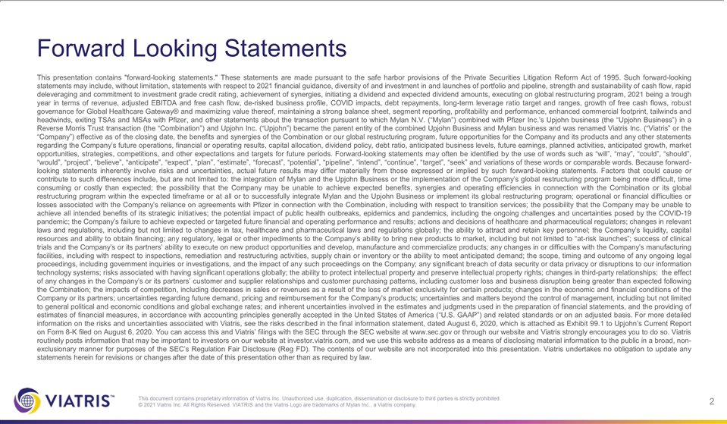

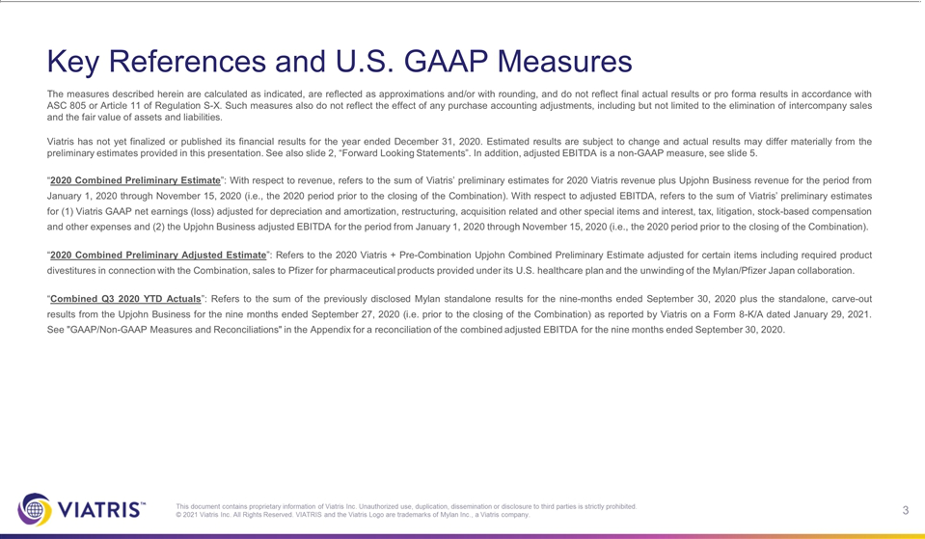

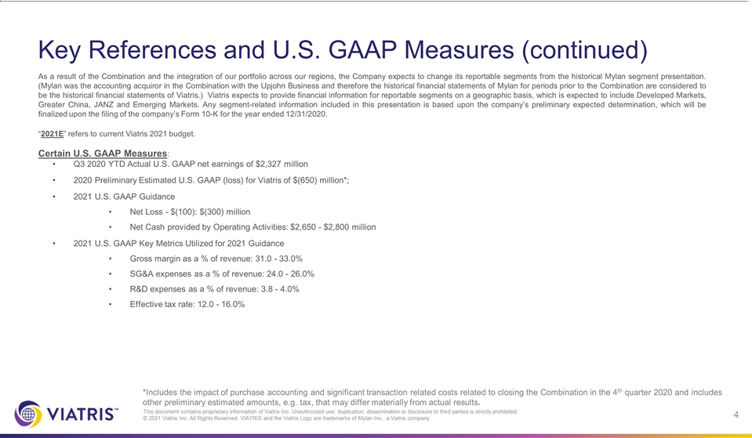

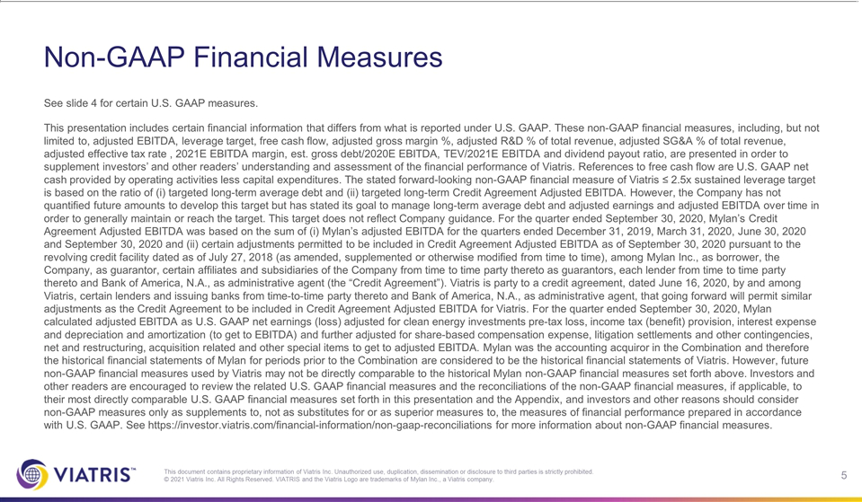

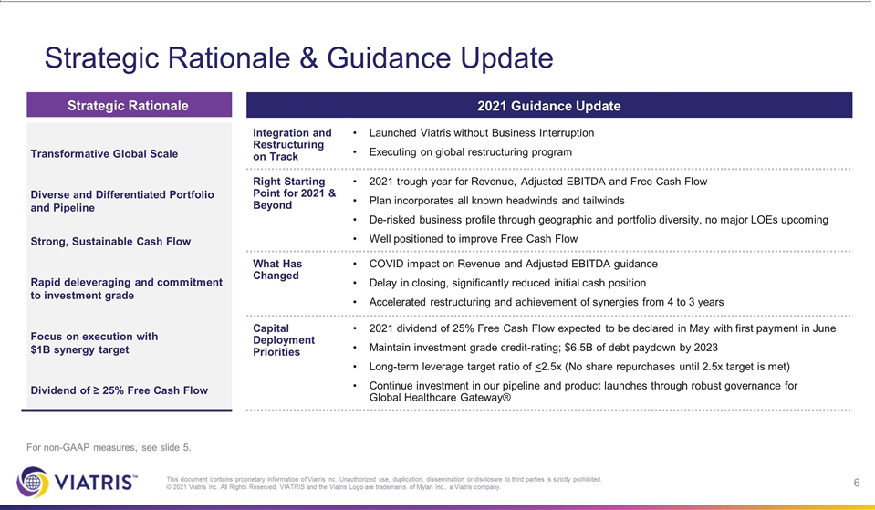

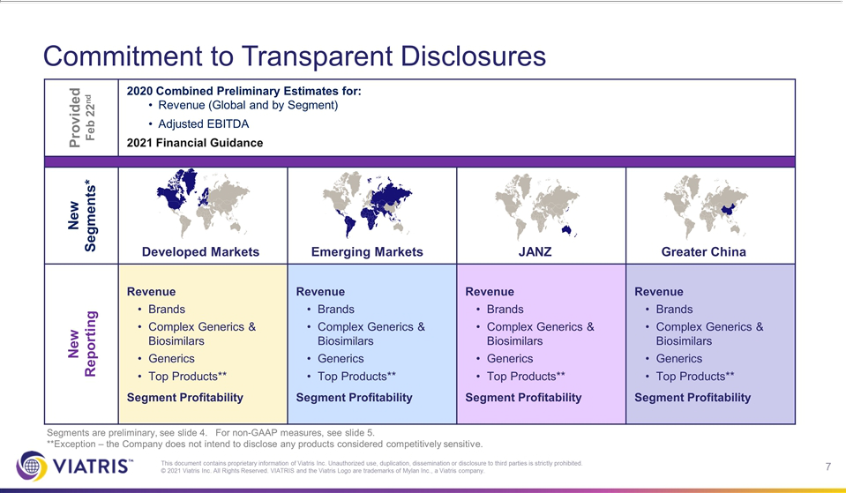

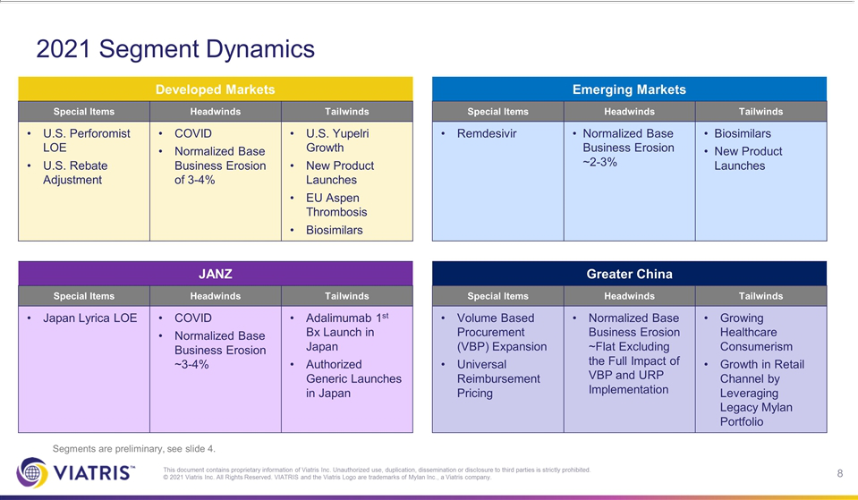

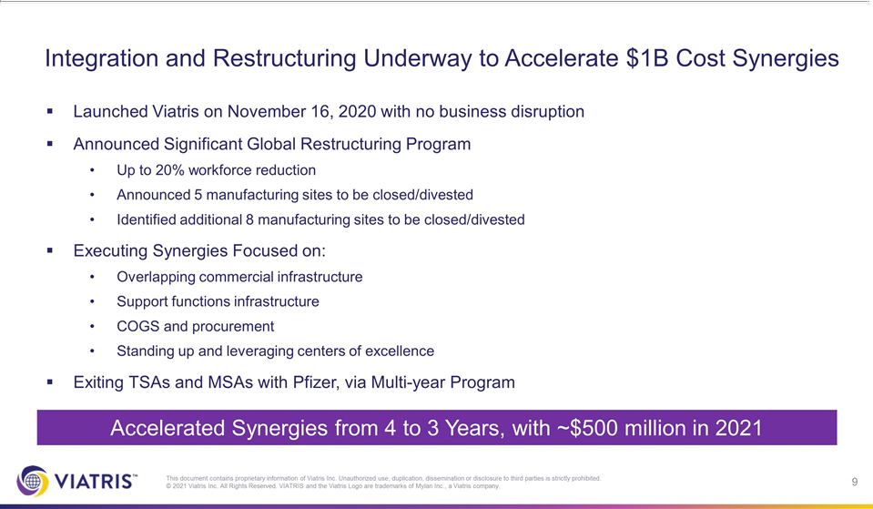



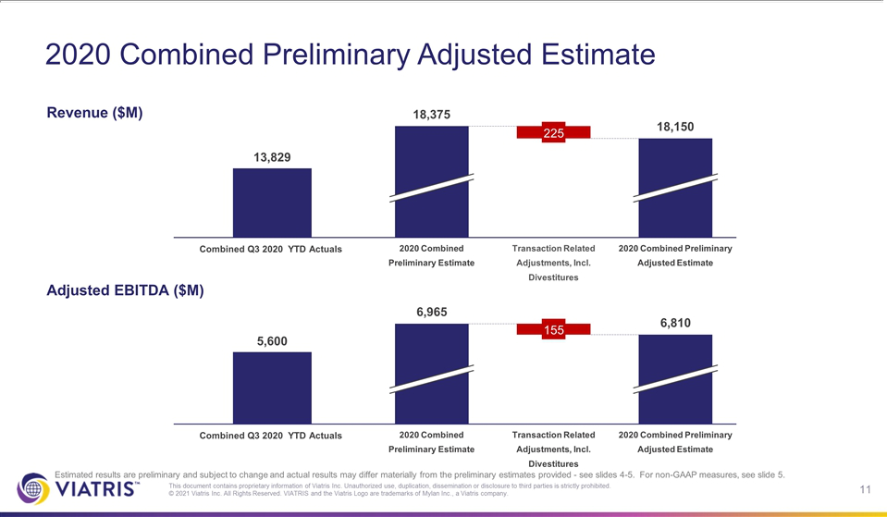

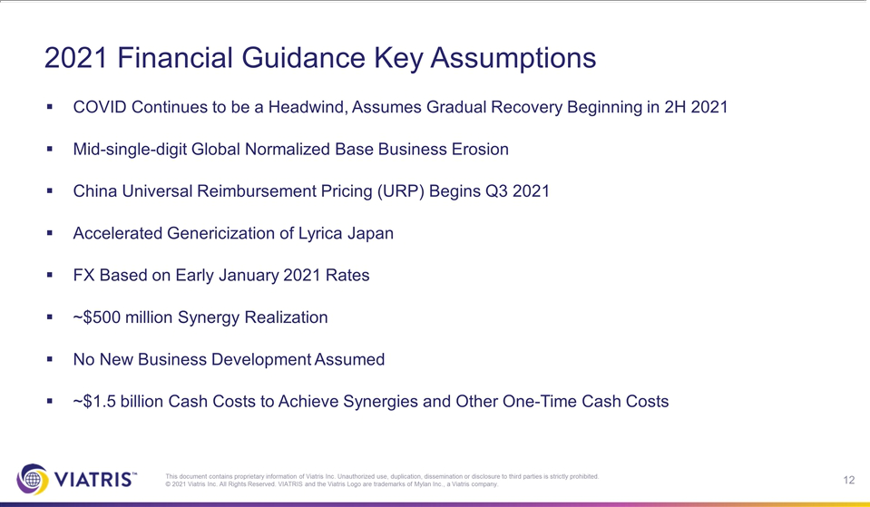

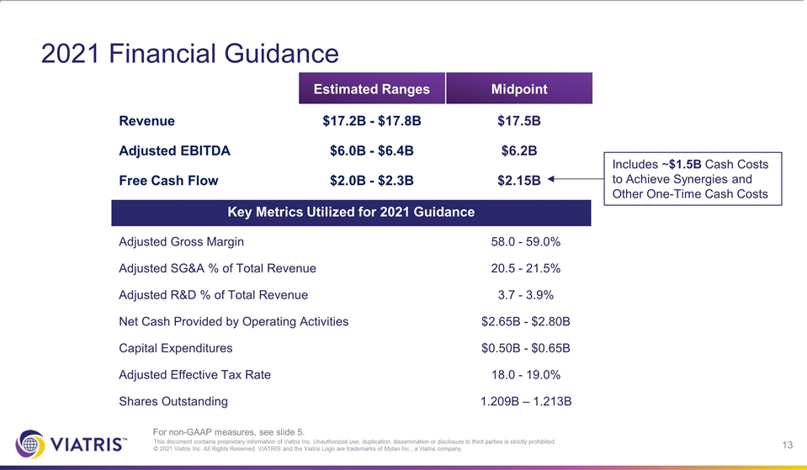

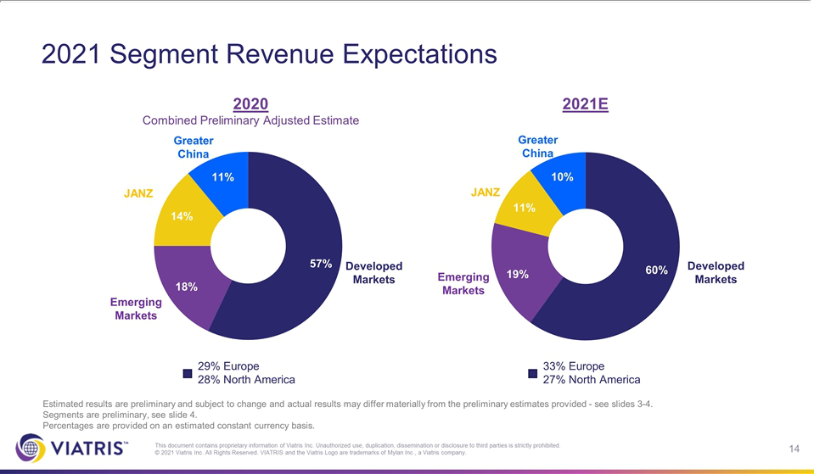

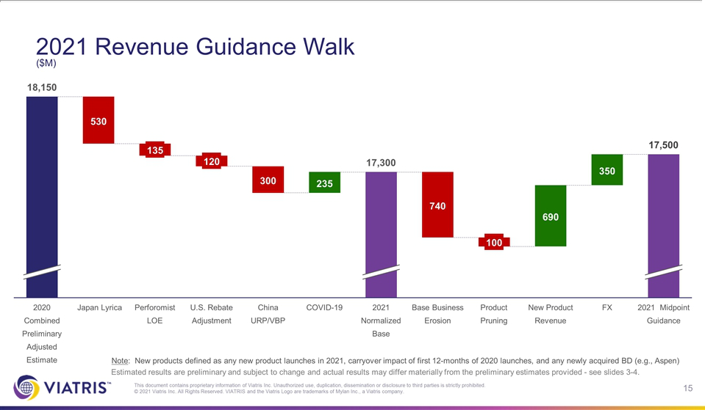

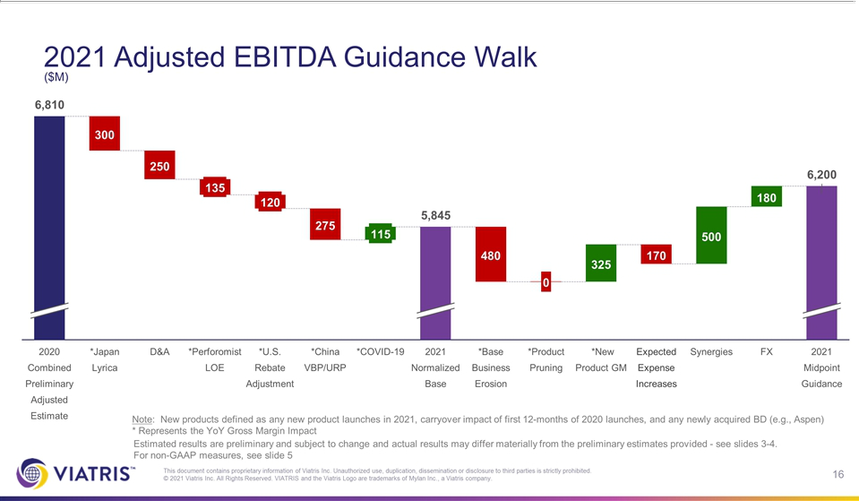

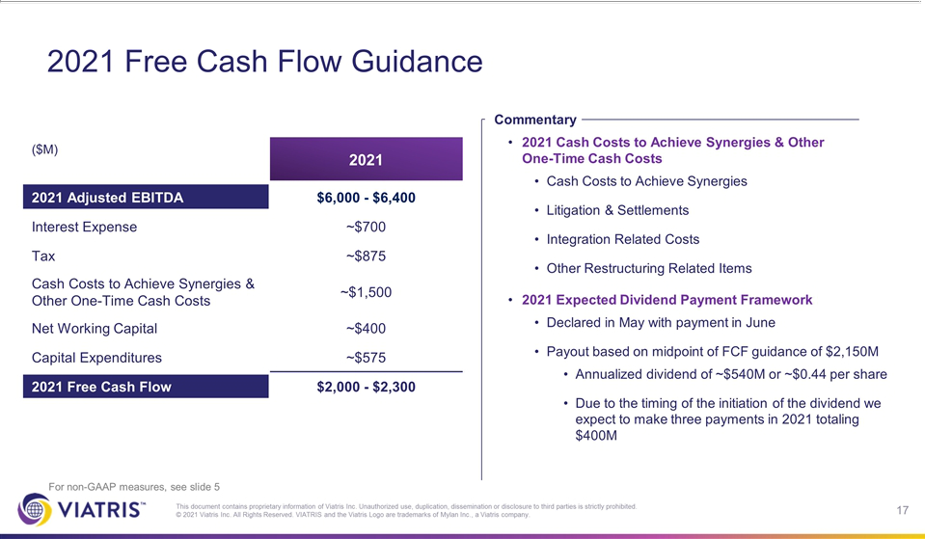

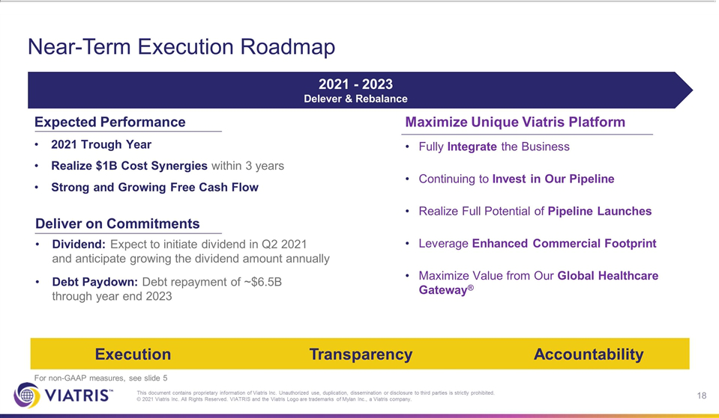



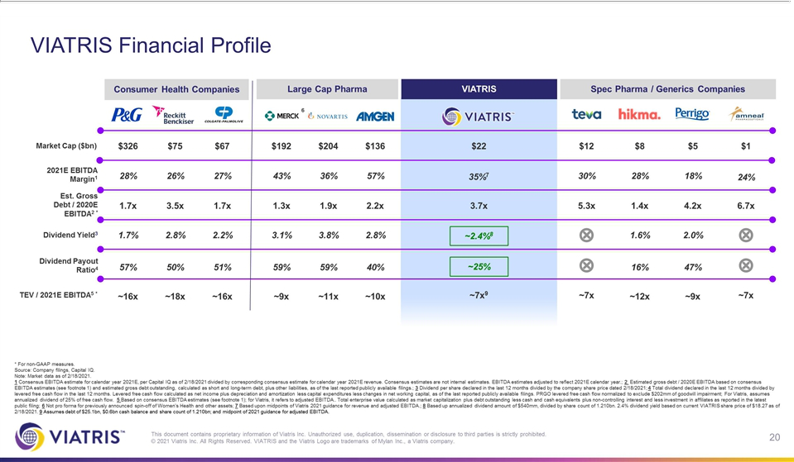

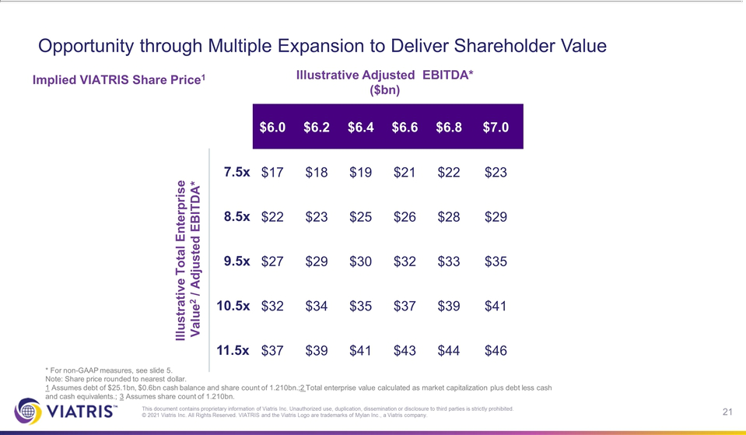

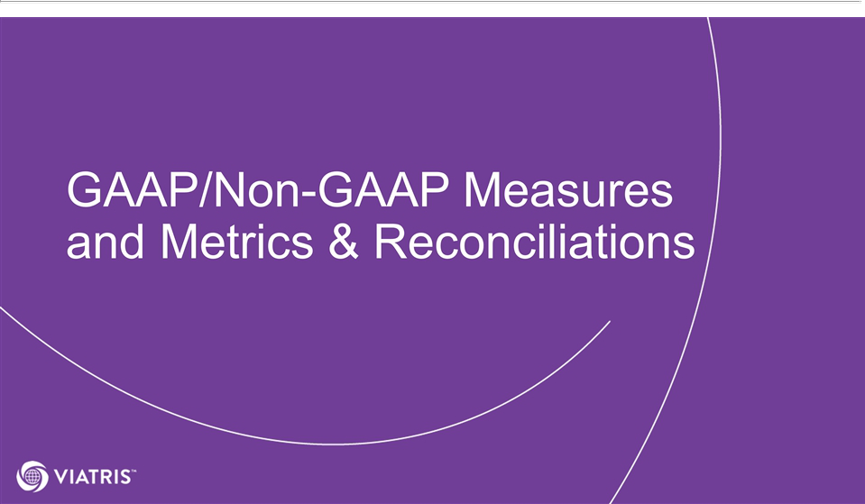

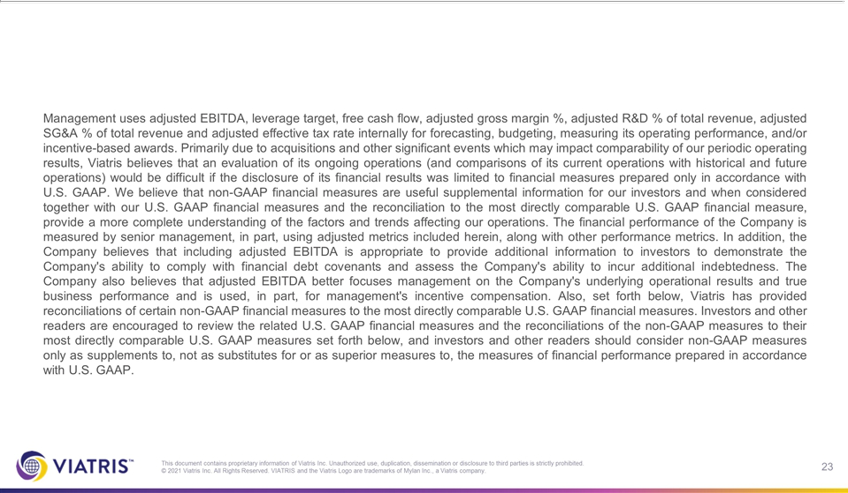

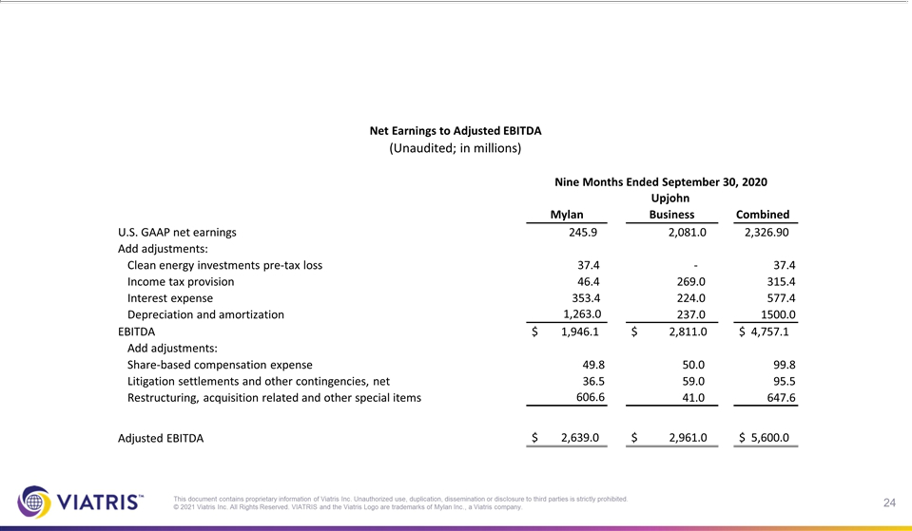

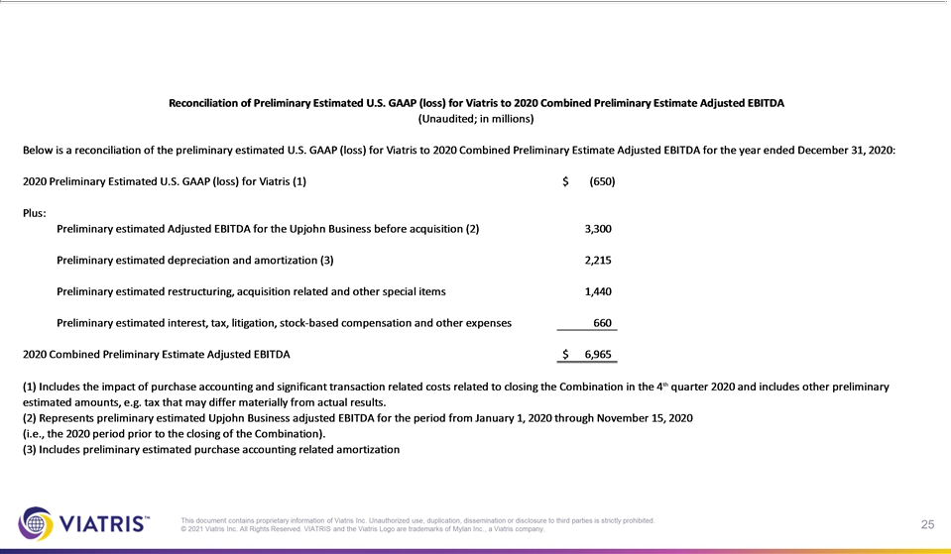

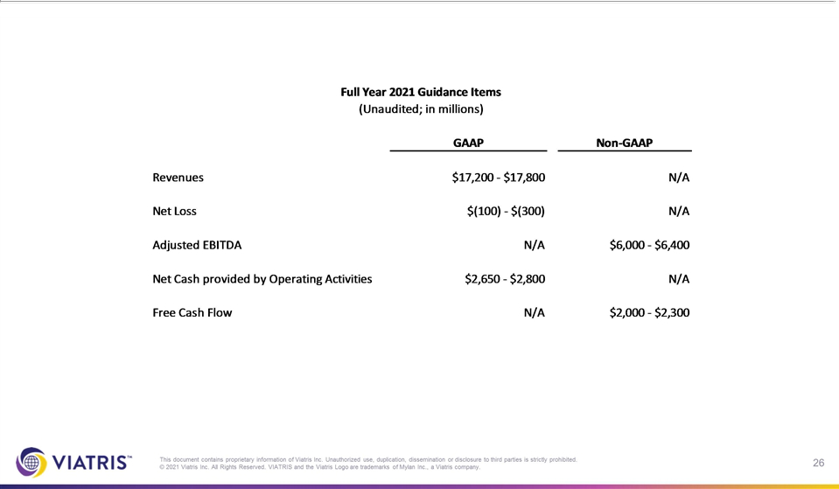

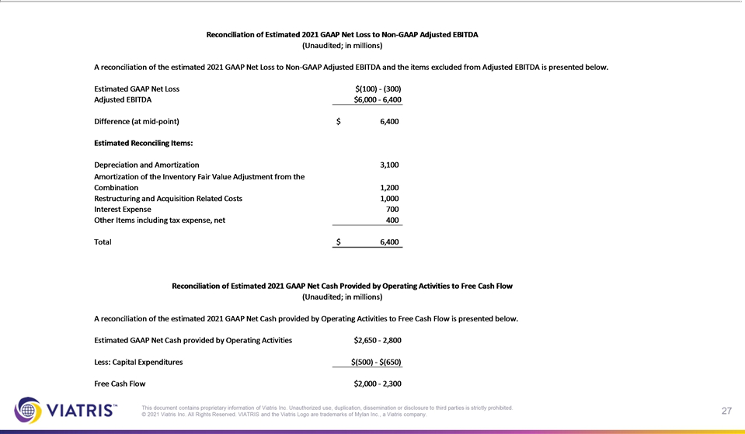

Exhibit 99.2


Viatris Inc. Announces 2021 Financial Guidance and Reaffirms Strategic and Financial Commitments

PITTSBURGH, February 22, 2021 – Viatris Inc. (NASDAQ: VTRS) today announced its 2021 financial guidance and reaffirmed its commitment to rapid de-leveraging, to enhancing and growing free cash flows, particularly following the phasing out of one-time and other stand up costs, to initiating a dividend, and to delivering total shareholder return (TSR).

2021 Financial Guidance

 | Range |  |  | Midpoint
 | (Billions) |  |  | (Billions)
Revenue | $17.2 | - $17.8 |  | $17.5
Adjusted EBIDTA (1) | $6.0 | - $6.4 |  | $6.2
Free Cash Flow (1) | $2.0 | - $2.3 |  | $2.15

(1) Non-GAAP financial measures. Please see “Non-GAAP Financial Measures” for additional information.

The 2021 Free Cash Flow guidance includes $1.5 billion cash cost to achieve synergies and other one-time cash costs.

Viatris CEO Michael Goettler said, “The strategic rationale for creating Viatris is as compelling today as when we announced the transaction to create this new company in July 2019. We launched Viatris with a TSR-focused operating model and a commitment to maintaining a strong balance sheet. As we previously stated, our company’s priorities in the first three years as we stand up Viatris will be predominately focused on rebalancing the business, generating strong and growing free cash flows, and rapidly de-leveraging.

“We are confident that our financial guidance for 2021 is the right starting point for Viatris and continue to expect 2021 to be our trough year in terms of revenue, adjusted EBITDA and free cash flow, reflecting a balanced view of both near-term tailwinds and headwinds, particularly given the delay in closing of the combination between Mylan and Pfizer’s Upjohn business,” Goettler said.

Goettler continued, “Our Global Healthcare Gateway® will fuel our future growth by leveraging our own diverse portfolio and pipeline, as well as those of our current and future partners through our unmatched global infrastructure, and significant scientific, manufacturing and commercial capabilities, all while executing on our mission to empower people worldwide to live healthier at every stage of life. We also look forward to meeting our commitment to provide a longer-term financial outlook in the coming months.”

Viatris president Rajiv Malik said, “Since we launched Viatris approximately 90 days ago, we have taken swift and decisive action to rebalance and position our business to succeed and compete in the current environment. This includes our multi-year global restructuring program we expect will accelerate the achievement of our $1 billion in cost synergies in three years, instead of our initial four-year timeframe, and will position us to continue to optimize our unique platform over the long term. We have made significant progress on this program, including taking steps to optimize our commercial and functional infrastructure, consolidate manufacturing sites and implement centers of excellence to enhance innovation and efficiency. We expect this work will enable us to create a more flexible, efficient Viatris better positioned to achieve our long-term objectives. We are looking forward to maximizing our anticipated new product launches, including biosimilars and complex generics, through our enhanced combined global manufacturing and commercial platforms.”

Initiating 2021 Dividend and Reaffirming Capital Allocation Priorities

The Viatris Board has undertaken a comprehensive review of management’s operating plan for 2021 and unanimously supports the Company’s priorities for the next few years, including its priorities for capital allocation and initiating an annualized dividend of at least 25% of free cash flow for 2021. Based on the mid-point of Viatris’ 2021 free cash flow guidance of $2.15 billion, the Board expects the Company to pay an annualized dividend of approximately $540 million, or $0.44 per share, with the expectation to grow the dividend amount thereafter. Due to the timing of the initiation of the dividend we expect to make three payments in 2021 totaling approximately $400 million. The Company expects the first quarterly dividend of $0.11 per share to be declared in May 2021 and distributed in June 2021, subject to the Board’s first quarter 2021 review.

The Company expanded its commitment to debt paydown and to maintaining its investment grade credit rating, and now expects to repay approximately $6.5 billion in debt by the end of 2023. In addition, the Company is targeting a long-term leverage ratio of 2.5x, with a range of 2.2x to 2.8x. The Company also continues to be committed not to institute any share repurchase programs until the leverage ratio is at least <2.5x.

Viatris chief financial officer Sanjeev Narula said, “Our disciplined approach and financial commitments of de-levering the balance sheet while delivering value to shareholders are paramount to our priorities and operational thesis. This will be supported by our expectation to enhance cash flows and create more financial flexibility. We are confident that 2021 will be our trough year as we have no significant additional near-term product Loss of Exclusivities.”

 | Key Metrics Utilized for 2021 Financial Guidance
 | Adjusted Gross Margin (1) | 58.0% - 59.0%
 | Adjusted SG&A % of Total Revenue (1) | 20.5% - 21.5%
 | Adjusted R&D % of Total Revenue (1) | 3.7% | - 3.9%
 | Net Cash Provided by Operating Activities | $2.65 | - $2.80 billion
 | Capital Expenditures | $0.5 - $0.65 billion
 | Adjusted Effective Tax Rate (1) | 18.0% - 19.0%
 | Shares Outstanding | 1.209 | - 1.213 billion
- Non-GAAP financial measures. Please see “Non-GAAP Financial Measures” for additional information.

 | Key Exchange Rates Used for 2021 Guidance
 | Australian Dollar ($ / AUD) | 1.37
 | British Pound ($ / GBP) | 0.76
 | Canadian Dollar ($ / CAD) | 1.31
 | China Renminbi ($ / CNY) | 6.69
 | Euro ($ / EUR) | 0.84
 | Indian Rupee ($ / INR) | 73.76
 | Japanese Yen ($ / JPY) | 104.77
 | South Korean Won ($ / KRW) | 1,138.64

Conference Call

As previously announced, Viatris will host a conference call at 8 a.m. ET today, Feb. 22, 2021, to discuss 2021 financial guidance.

The briefing can be accessed live by calling (855) 493-3607 or (346) 354-0950 for international callers (ID#: 3235536) or at the following address on

the company’s website: investor.viatris.com. The slide presentation and replay of the webcast also will be available on the website.

Non-GAAP Financial Measures

This press release includes the presentation and discussion of certain financial information that differs from what is reported under accounting principles generally accepted in the United States of America (“U.S. GAAP”). These non-GAAP financial measures, including, but not limited to, adjusted EBITDA, free cash flow, adjusted gross margin, adjusted R&D and as a % of total revenues, adjusted SG&A and as a % of total

revenues, adjusted effective tax rate and long-term leverage ratio target of £ 2.5x, are presented in order to supplement investors’ and other readers’ understanding and assessment of the financial performance of Viatris. Viatris has provided reconciliations of such non-GAAP financial measures to the most directly comparable U.S. GAAP financial measures. Investors and other readers are encouraged to review the related U.S. GAAP financial measures and the reconciliations of the non-GAAP measures to their most directly comparable U.S. GAAP measures set forth in this press release, and investors and other readers should consider non-GAAP measures only as supplements to, not as substitutes for or as superior measures to, the measures of financial performance prepared in accordance with U.S. GAAP.

The stated forward-looking non-GAAP financial measure of Viatris targeting a long-term leverage ratio of 2.5x, with a range of 2.2x to 2.8x, is based on the ratio of (i) targeted long-term average debt and (ii) targeted long-term Credit Agreement Adjusted EBITDA. However, Viatris has not quantified future amounts to develop this target but has stated its goal to manage long-term average debt and adjusted EBITDA over time in order to generally maintain or reach the target. This target does not reflect company guidance. For the quarter ended September 30, 2020, Mylan’s Credit Agreement Adjusted EBITDA was based on the sum of (i) Mylan’s adjusted EBITDA for the quarters ended December 31, 2019, March 31, 2020, June 30, 2020 and September 30, 2020 and (ii) certain adjustments permitted to be included in Credit Agreement Adjusted EBITDA as of September 30, 2020 pursuant to the revolving credit facility dated as of July 27, 2018 (as amended, supplemented or otherwise modified from time to time), among Mylan Inc., as borrower, the Company, as guarantor, certain affiliates and subsidiaries of the Company from time to time party thereto as guarantors, each lender from time to time party thereto and Bank of America, N.A., as administrative agent (the “Credit Agreement”). Viatris is party to a credit agreement, dated June 16, 2020, by and among Viatris, certain lenders and issuing banks from time-to-time party thereto and Bank of America, N.A., as administrative agent, that going forward will permit similar adjustments as the Credit Agreement to be included in Credit Agreement Adjusted EBITDA for Viatris. For the quarter ended September 30, 2020, Mylan N.V. (“Mylan”) calculated adjusted EBITDA as U.S. GAAP net earnings (loss) adjusted for clean energy investments pre-tax loss, income tax (benefit) provision, interest expense and depreciation and amortization (to get to EBITDA) and further adjusted for share-based compensation expense, litigation settlements and other contingencies, net and restructuring, acquisition related and other special items to get to adjusted EBITDA. Mylan was the accounting acquiror in the transaction pursuant to which Mylan combined with Pfizer Inc.’s Upjohn business (the “Upjohn Business”) in a Reverse Morris Trust transaction (the “Combination”) and therefore the historical financial statements of Mylan for periods prior to the Combination are considered to be the historical financial statements of Viatris. However, future non-GAAP financial measures used by Viatris may not be directly comparable to the historical Mylan non-GAAP financial measures set forth above.

Full Year 2021 Guidance Items

(Unaudited; in millions)

 | GAAP |  |  | Non-GAAP
Revenue | $17,200 | - $17,800 |  | N/A
Net Loss | $(100) | - $(300) |  | N/A
Adjusted EBIDTA | N/A |  |  | $6,000 - $6,400
Net Cash provided by Operating Activities | $2,650 | - $2,800 |  | N/A
Free Cash Flow | N/A |  |  | $2,000 - $2,300

Reconciliation of Estimated 2021 GAAP Net Loss to Non-GAAP Adjusted EBITDA

(Unaudited; in millions)

A reconciliation of the estimated 2021 GAAP Net Loss to Non-GAAP Adjusted EBITDA and the items excluded from Adjusted EBITDA is presented below.

 | Estimated GAAP Net Loss |  | $(100) – $(300)
 | Adjusted EBIDTA |  | $6,000 - $6,400
 | Difference at Mid-Point |  | $6,400
Estimated Reconciling Items:
 | Depreciation and Amortization |  | $3,100
 | Amortization of the Inventory Fair Value Adjustment from the Combination |  | $1,200
 | Restructuring and Acquisition Related Costs |  | $1,000
 | Interest Expense |  | $700
 | Other Items included tax expense, net |  | $400
Total |  |  | $6,400

Reconciliation of Estimated 2021 GAAP Net Cash Provided by Operating Activities to Free Cash Flow

(Unaudited, in millions)

A reconciliation of the estimated 2021 GAAP Net Cash provided by Operating Activities to Free Cash Flow is presented below.

 | Estimated GAAP Net Cash provided by Operating Activities |  |  | $2,650 - $2,800
 | Less; Capital Expenditures |  |  |  | $ (500) - $(650)
 | Free Cash Flow |  |  | $2,000 - $2,300
 | Key Metrics Utilized for 2021 Guidance
 | (Unaudited; in millions, except percentages)
 |  |  | GAAP |  |  |  | Non-GAAP
 | Gross margin as a % of revenue |  | 31.0 | – 33.0% |  |  | 58.0 | – 59.0%
 | SG&A expenses as a % of revenue |  | 24.0 | – 26.0% |  |  | 20.5 | – 21.5%
 | R&D expenses as a % of revenue |  | 3.8 | – 4.0% |  |  | 3.7 | – 3.9%
 | Net Cash provided by Operating Activities |  | $2,650 - $2,800 |  |  |  |  | N/A
 | Capital Expenditures |  | $500 - $650 |  |  |  |  | N/A
 | Effective Tax Rate |  | 12.0 | – 16.0% |  |  | 18.0 | – 19.0%
 | Shares Outstanding |  | 1,209 – 1,213 |  |  |  |  | N/A

2021 Non-GAAP Financial Metrics

The Non-GAAP financial metric Adjusted Gross Margin as a percentage of Revenues excludes the impact of Depreciation and Amortization, the Amortization of the Inventory Fair Value Adjustment from the Combination and certain Restructuring and Acquisition Related Costs when compared to the GAAP Gross Margin as a percentage of Revenues.

The Non-GAAP financial metric Adjusted R&D as a percentage of Revenues excludes the impact of certain Restructuring and Acquisition Related Costs and other items when compared to the GAAP R&D as a percentage of Revenues.

The Non-GAAP financial metric Adjusted SG&A as a percentage of Revenues excludes the impact of certain Restructuring and Acquisition Related Costs and other items when compared to the GAAP SG&A as a percentage of Revenues.

The Non-GAAP financial metric Adjusted Effective Tax Rate percentage the impact of non-GAAP adjustments and other tax related items when compared to the GAAP Effective Tax Rate percentage.

About Viatris

Viatris Inc. (NASDAQ: VTRS) is a new kind of healthcare company, empowering people worldwide to live healthier at every stage of life.

We provide access to medicines, advance sustainable operations, develop innovative solutions and leverage our collective expertise to connect more people to more products and services through our one-of-a-kind Global Healthcare Gateway®. Formed in November 2020 through the combination of Mylan and Pfizer’s Upjohn business, Viatris brings together scientific, manufacturing and distribution expertise with proven regulatory, medical and commercial capabilities to deliver high-quality medicines to patients in more than 165 countries and territories. Viatris’ portfolio comprises more than 1,400 approved molecules across a wide range of therapeutic areas, spanning both non-communicable and infectious diseases, including globally recognized brands, complex generic and branded medicines, a growing portfolio of biosimilars and a variety of over-the-counter consumer products. With a global workforce of approximately 45,000, Viatris is headquartered in the U.S., with global centers in Pittsburgh, Shanghai and Hyderabad, India. Learn more at viatris.com and investor.viatris.com, and connect with us on Twitter at @ViatrisInc, LinkedIn and YouTube.

Forward-Looking Statements

This release contains “forward-looking statements.” These statements are made pursuant to the safe harbor provisions of the Private Securities Litigation Reform Act of 1995. Such forward-looking statements may include, without limitation, statements with respect to 2021 financial guidance, rapid de-leveraging, debt repayments, long-term leverage ratio target and ranges, enhancement and growth of free cash flows, initiating a dividend and the expected dividend amounts, delivering total shareholder return (TSR), maintaining a strong balance sheet, rebalancing the business, 2021 being a trough year in terms of revenue, adjusted EBITDA and free cash flow, tailwinds and headwinds, our Global Healthcare Gateway® fueling our future growth, executing on our mission to empower people worldwide to live healthier at every stage of life, meeting our commitment to provide a longer-term

financial outlook in the coming months, positioning our business to succeed and compete in the current environment, maintaining investment grade credit rating, not instituting any share repurchase programs until the leverage ratio is at less than 2.5x, financial flexibility, delivering value to shareholders being paramount to our priorities and operational thesis, the benefits and synergies of the Combination or our global restructuring program, future opportunities for the Company and its products and any other statements regarding the Company’s future operations, financial or operating results, capital allocation, anticipated business levels, planned activities, anticipated growth, market opportunities, strategies, competitions, and other expectations and targets for future periods. Forward-looking statements may often be identified by the use of words such as “will”, “may”, “could”, “should”, “would”, “project”, “believe”, “anticipate”, “expect”, “plan”, “estimate”, “forecast”, “potential”, “pipeline”, “intend”, “continue”, “target”, “seek” and variations of these words or comparable words. Because forward-looking statements inherently involve risks and uncertainties, actual future results may differ materially from those expressed or implied by such forward-looking statements. Factors that could cause or contribute to such differences include, but are not limited to: the integration of Mylan and the Upjohn Business or the implementation of the Company’s global restructuring program being more difficult, time consuming or costly than expected; the possibility that the Company may be unable to achieve expected benefits, synergies and operating efficiencies in connection with the Combination or its global restructuring program within the expected timeframe or at all or to successfully integrate Mylan and the Upjohn Business or implement its global restructuring program; operational or financial difficulties or losses associated with the Company’s reliance on agreements with Pfizer in connection with the Combination, including with respect to transition services; the possibility that the Company may be unable to achieve all intended benefits of its strategic initiatives; the potential impact of public health outbreaks, epidemics and pandemics, including the ongoing challenges and uncertainties posed by the COVID-19 pandemic; the Company’s failure to achieve expected or targeted future financial and operating performance and results; actions and decisions of healthcare and pharmaceutical regulators; changes in relevant laws and regulations, including but not limited to changes in tax, healthcare and pharmaceutical laws and regulations globally; the ability to attract and retain key personnel; the Company’s liquidity, capital resources and ability to obtain financing; any regulatory, legal or other impediments to the Company’s ability to bring new products to market, including but not limited to “at-risk launches”; success of clinical trials and the Company’s or its partners’ ability to execute on new product opportunities and develop, manufacture and commercialize products; any changes in or difficulties with the Company’s manufacturing facilities, including with respect to inspections, remediation and restructuring activities, supply chain or inventory or the ability to meet anticipated demand; the scope, timing and outcome of any ongoing legal proceedings, including government inquiries or investigations, and the impact of any such proceedings on the Company; any significant breach of data security or data privacy or disruptions to our information technology systems; risks associated with having significant operations globally; the ability to protect intellectual property and preserve intellectual property rights; changes in third-party relationships; the effect of

any changes in the Company’s or its partners’ customer and supplier relationships and customer purchasing patterns, including customer loss and business disruption being greater than expected following the Combination; the impacts of competition, including decreases in sales or revenues as a result of the loss of market exclusivity for certain products; changes in the economic and financial conditions of the Company or its partners; uncertainties regarding future demand, pricing and reimbursement for the Company’s products; uncertainties and matters beyond the control of management, including but not limited to general political and economic conditions and global exchange rates; and inherent uncertainties involved in the estimates and judgments used in the preparation of financial statements, and the providing of estimates of financial measures, in accordance U.S. GAAP and related standards or on an adjusted basis. For more detailed information on the risks and uncertainties associated with Viatris, see the risks described in the final information statement, dated August 6, 2020, which is attached as Exhibit 99.1 to Upjohn’s Current Report on Form 8-K filed on August 6, 2020. You can access this and Viatris’ filings with the SEC through the SEC website at www.sec.gov or through our website and Viatris strongly encourages you to do so. Viatris routinely posts information that may be important to investors on our website at investor.viatris.com, and we use this website address as a means of disclosing material information to the public in a broad, non-exclusionary manner for purposes of the SEC’s Regulation Fair Disclosure (Reg FD). The contents of our website are not incorporated into this release. Viatris undertakes no obligation to update any statements herein for revisions or changes after the date of this release other than as required by law.

Contacts:

Media:

+1.724.514.1968

Communications@viatris.com

Jennifer Mauer

Head of Global Communications and Corporate Brand

Jennifer.Mauer@viatris.com

Investors:

+1.724.514.1813

InvestorRelations@viatris.com

Bill Szablewski

Head of Capital Markets

William.Szablewski@viatris.com

Melissa Trombetta

Head of Investor Relations

Melissa.Trombetta@viatris.com

###

